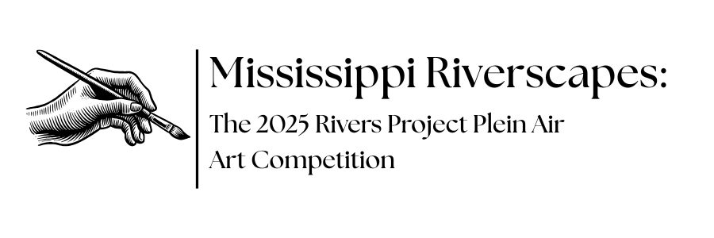
Please review the information provided below to ensure you have a full understanding of the operations of this art competition. Any additional questions can be addressed by contacting the National Great Rivers Museum. Proper communication outlets can be found at the bottom of this document.
CONTEST REGULATIONS_______________________________________________
Eligibility
This is a Plein Air (open air) art competition open to all professional and amateur artists ages 16+.
Medium
Any 2D painting or drawing medium may be used, including but not limited to: charcoal, colored pencil, pastel, watercolor, acrylics, oil paint, etc. Works must be ready to hang without any additional work on the part of museum staff. No photography, computer generated images, or sculpture will be accepted.
All unframed works must not exceed 16”x20”. If framed in addition to these dimensions, frames must not be more than 3” thick.
Subject
Only landscapes will be accepted. No still life, portraits, or other subject matter. All landscapes must reflect the real-life scenes as viewed at that particular location, at that particular time. Scenes should not be posed or physically altered in any way. People and animals may be included in the scene if present but must not be the main focus.
Location
All paintings/drawings must be completed at one of the following Rivers Project locations:
- Silo Access Area, Pike County MO
- Calumet Creek Natural Area, Pike County MO
- Lincoln Shields Recreation Area, West Alton MO
- Ellis Bay/Rivers Project Area, West Alton MO
- Ellis Island, West Alton, MO
- Heron Pond, West Alton, MO
- Illinois Esplanade, East Alton IL (Next to the National Great Rivers Museum)
- Low Water Access Area, Granite City IL (also known as Chouteau Island Fishing Area)
These locations can all be found on the attached contest map. Locations are subject to closures based on high water levels and other unforeseen circumstances and it is the responsibility of the artist to verify the accessibility of any site before attempting a visit.
Each painting/drawing must be completed in one single outdoor session at a single designated location. Artists may visit multiple locations but are limited to one submission per location, per artist, for an allowed total of 8 submissions. Artwork is not permitted to be completed in a studio setting or drawn from a photograph or other reference material besides the live location.
The location for each work must be specified upon submission, or the work will not be included in the contest.
Time Frame
All paintings/drawings must be completed during the designated time period of June 1st -June 22nd, 2025 and must be delivered in-person to the National Great Rivers Museum no later than 5:00 p.m. on June 22nd, 2025. Any submissions received after this time will not be included in the contest or following exhibition.
Judging will take place the week of June 23rd, with an awards ceremony to announce the winners on July 12th, 2025 at 3:30 p.m. at the National Great Rivers Museum.
All submitted works will be exhibited in the classroom of the National Great Rivers Museum starting Monday, July 14th with the exhibit running until Sunday, September 14th, 2025.
All submissions must be picked up between September 20th and September 26th, 2025 unless an alternative date has been scheduled with the contest coordinator. Artists may not remove their work from the exhibit prior to the pickup week. All requests for alternative dates must be scheduled prior to the end of the pickup week.
Judging
The exhibit will be juried by the Jacoby Arts Center Exhibition Committee and guest judges including prominent artists, art educators and gallery owners. The following criteria will be used:
Visual Impact — overall attraction and impact, eye catching, intriguing, compelling.
Craftsmanship — Drawing, values, skill of the medium, paint handling, presentation.
Composition — The unity of a painting, effective use of elements and principles.
Color — Not just bright color, but color harmony. Color relationships. Color balance. It can be subdued color or strong color. The effect of light permeating a piece. You say, “I like the color; it feels right.”
Creativity — innovative use of imagery or technique, originality. Stands out from other works.
Follows all Criteria in regulations
All judging will take place the week of June 23rd, 2025. Best of Show, First Runner-Up, and Honorable Mention winners will be selected. Winners will be announced during the Awards Ceremony at 3:30 p.m. at the National Great Rivers Museum on July 12th, 2025.
Prizes
First Place: Weekend artist retreat at the Green Tree Inn in Elsah, IL (Est. value: $500)
First Runner-Up: $100 cash prize from Meeting of the Rivers Foundation
Honorable Mention: Gift bag from Great Rivers and Routes Tourism Bureau, including a pottery item from Mississippi Mud Pottery
Sales
Artists may choose to list their works for sale, at their own discretion. Artists who are interested in selling their work must specify upon registration which works are for sale, as well as their price and contact information for interested buyers. Prices will not be listed next to works in the exhibit; however, there will be a separate display at the entrance to the exhibit listing artist names, works that are for sale, prices, and contact information. All arrangements between buyers and sellers are entirely up to the artist and will not involve the National Great Rivers Museum or Jacoby Arts Center.

SUBMISSION INSTRUCTIONS _________________________________
Submissions will be accepted June 1st – June 22nd, 2025. Each artist must register online at the following link.
https://www.mtrf.org/plein-air-art/
Physical entries must be brought to the museum (open 9-5 daily) by 5:00 p.m. on June 22nd, 2025.
Entry Fee
The entry fee is a one-time, non-refundable fee of $25.00 per artist. Each artist may submit up to one artwork per location, for a total of 8 possible submissions. Fees may be paid through the registration link above.
Framing/Hanging
All works on paper or board must be framed in a professional manner with braided wire attached for hanging and will be hung from a single hook as part of the display. Do NOT use saw-tooth hangers, string, or single strand aluminum wire. Use braided wire specifically made for your picture/frame weight. Wire must be attached using screws or another mechanical form of attachment. Command strips, tape, or other forms of adhesive are not sufficient. Frames may not be more than 3” thick (ie. should not add more than 6” total to the width or length of your artwork)
Works on canvas may be hung without frames but must be finished on the edges (ie. painted) to a display-level quality.
The National Great Rivers Museum and Jacoby Arts Center are not responsible for any damages to submitted works; make sure all hanging hardware is secured in such a way that they will not fall off of the wall and break.
Each artwork must have the artist’s name, location depicted, and title of work written on, or attached to, the back of the picture frame (if framed) or the canvas (if unframed). This information must be attached securely; business cards tucked into the back of the frame easily fall out and are not sufficient identification unless taped to the frame. If you are using a business card as identification, ensure that the title and location of your work is also clearly written on the back of the frame.
DISCLAIMER________________________________________________________
Photographs of submitted artwork will be used in future promotional materials. By submitting your artwork, you are giving the National Great Rivers Museum and Jacoby Arts Center permission to photograph your work for this purpose.
The National Great Rivers Museum and Jacoby Arts Center are not responsible for any damages to art entries. Participants take full responsibility for ensuring that their entries are framed appropriately and equipped with sufficient hanging hardware to prevent damage to the artwork.
Any artwork not picked up within the specified time frame or at a later, previously agreed-upon date will be forfeited to the National Great Rivers Museum and become a donation to the Meeting of the Rivers Foundation. These works will not be returned outside of this time frame.

CONTACT INFORMATION______________________________________________
Physical entries must be delivered to the following address:
National Great Rivers Museum
2 Lock and Dam Way
East Alton, Illinois 62024
Open Daily 9:00 a.m. – 5:00 p.m.
For questions, please contact the contest coordinator, Elise Ratcliff, at the National Great Rivers Museum by calling 618-462-6979, or by email at elise.m.ratcliff@usace.army.mil.

