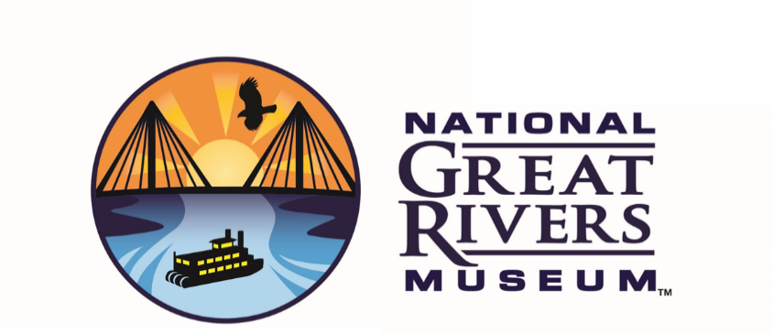

Every Kid Outdoors
Teacher Questionnaire

SCHOOL INFORMATION
Please complete the following teacher questionnaire in order to schedule your EKO field trip to the National Great Rivers Museum and Melvin Price Lock and Dam.

Your e-mail address: Click or tap here to enter text.
Name: Click or tap here to enter text.
Name of School: Click or tap here to enter text.
School district: Click or tap here to enter text.
School Address: Click or tap here to enter text.
Street: Click or tap here to enter text.
City: Click or tap here to enter text.
State: Click or tap here to enter text.
Zip Code: Click or tap here to enter text.
School Phone Number: Click or tap here to enter text.
Alternate Phone Number: Click or tap here to enter text.
How many 4th grade classes will be participating? Click or tap here to enter text.
Please list the first and last name of each teacher participating and the approximate number of students in each class.Click or tap here to enter text.
Are there any special needs, if yes please explain. Click or tap here to enter text.
How early can you depart from school? Click or tap here to enter text.Click or tap here to enter text.
What time must you be back at school? Click or tap here to enter text.

TRANSPORTATION
All teachers must schedule their own buses and submit an EKO invoice along with a copy of the bus company invoice. The EKO invoice will be provided to you once you have scheduled your visit.

Does your district have their own buses? Yes☐ No☐
If your answer is yes, are you required to use them for travel? Yes ☐ No ☐
If your answer is no, which bus company do you typically use?
First Student ☐
Illinois Central ☐
Durham ☐

PROGRAM DETAILS
Please list three optional dates for your fieldtrip, according to your preference.
Field trips will be offered Wednesdays through Fridays during the months of March, April, and May.
Please be advised that offerings are subject to availability.

1st Click or tap to enter a date.
2nd Click or tap to enter a date.
3rd Click or tap to enter a date.

Please check two program topics that would be most appropriate for your students, according to your preference. If you have a special topic request, please describe in the last section, and we can try to accommodate your needs.
☐Engineering: Building Bridges
☐Managing the River: Floodplain Model
☐Watershed Run-off: Enviroscape Lesson
☐Other: Click or tap here to enter text.

Are you interested in your students touring the Melvin Price Lock and Dam?
Yes ☐ No ☐

Thank you for completing this survey!
Please save a copy for your records and send a copy to
Corrinne O’Brien
Corrinne.A.O’Brien@usace.army.mil
If you have additional questions please email or call
636-899-0050 / 636-544-7314

